PRACTICALS

PROGRAMMING WITH C

**Q. Write a C program to print “Hello World”.**

**CODE:**

#include<stdio.h>

int main()

{

printf(“Hello World\n”);

return 0;

}



**Q. Write a C program to swap two numbers.**

**CODE:**

#include<stdio.h>

int main()

{

int a=2,b=3;

printf(“The value of a is 2 and b is 3 before swapping.\n”);

a=a+b;

b=a-b;

a=a-b;

printf(“The value of a is %d and b is %d after swapping.\n”,a,b);

return 0;

}



**Q. Write a C program to swap two numbers with the use of a temporary variable.**

**CODE:**

#include<stdio.h>

int main()

{

int a,b,c;

printf(“Enter the value of a & b :”);

scanf(“%d%d”,&a,&b);

printf(“The value of a=%d and b=%d before swapping.\n”,a,b);

c=a+b;

a=c-a;

b=c-b;

printf(“The value of a=%d and b=%d after swapping.\n”,a,b);

return 0;

}

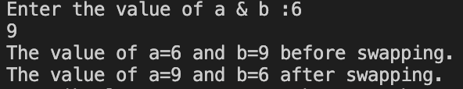

**Q. Write a C program for the addition of two numbers.**

**CODE:**

#include<stdio.h>

int main()

{

int a,b,sum;

printf(“Enter the value of a :”);

scanf(“%d”,&a);

printf(“Enter the value of b :”);

scanf(“%d”,&b);

sum=a+b;

printf(“The addition of a and b is %d\n”,sum);

return 0;

}

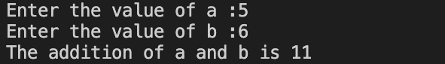

**Q. Write a C program for the subtraction of two numbers.**

**CODE:**

#include<stdio.h>

int main()

{

int a,b,sub;

printf(“Enter the value of a :”);

scanf(“%d”,&a);

printf(“Enter the value of b :”);

scanf(“%d”,&b);

sub=a-b;

printf(“The Subtraction of a and b is %d\n”,sub);

return 0;

}

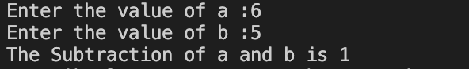

**Q. Write a C program for the multiplication of two numbers.**

**CODE:**

#include<stdio.h>

int main()

{

int a,b,mul;

printf(“Enter the value of a :”);

scanf(“%d”,&a);

printf(“Enter the value of b :”);

scanf(“%d”,&b);

mul=a*b;

printf(“The Multiplication of a and b is %d\n”,mul);

return 0;

}

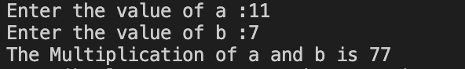

**Q. Write a C program for the division of two numbers.**

**CODE:**

#include<stdio.h>

int main()

{

int a,b,div;

printf(“Enter the value of a :”);

scanf(“%d”,&a);

printf(“Enter the value of b :”);

scanf(“%d”,&b);

div=a/b;

printf(“The Division of a and b is %d\n”,div);

return 0;

}

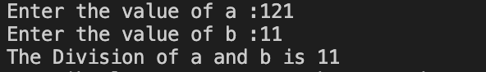

**Q. Write a C program to do all the arithmetic functions (addition, subtraction, multiplication and division) at once in one equation for five numbers.**

**CODE:**

#include<stdio.h>

int main()

{

float a,b,c,d,e,f;

printf(“Enter the value of a :”);

scanf(“%f”,&a);

printf(“Enter the value of b :”);

scanf(“%f”,&b);

printf(“Enter the value of c :”);

scanf(“%f”,&c);

printf(“Enter the value of d :”);

scanf(“%f”,&d);

printf(“Enter the value of e :”);

scanf(“%f”,&e);

f=((a+b-c)*d)/e;

printf(“The value of f=(a+b-c)*d)/e is %f\n”,f);

return 0;

}

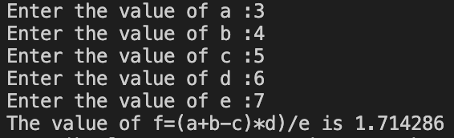

**Q. Write a C program to find the area of a circle.**

**CODE:**

#include<stdio.h>

#define PI 3.14

int main()

{

float r,a;

printf(“Enter the value of radius for a circle :”);

scanf(“%f”,&r);

a=PI*r*r;

printf(“The Area of the Circle is %f\n ”,a);

return 0;

}



**Q. Write a C program to find the circumference of a circle.**

**CODE:**

#include<stdio.h>

#define PI 3.14

int main()

{

float r,c;

printf(“Enter the value of radius for a circle :”);

scanf(“%f”,&r);

c=2*PI*r;

printf(“The Circumference of the Circle is %f\n ”,c);

return 0;

}



**Q. Write a C program to find the area of a triangle.**

**CODE:**

#include<stdio.h>

int main()

{

float b,h,a;

printf(“Enter the value of base for a triangle :”);

scanf(“%f”,&b);

printf(“Enter the value of height for a triangle :”);

scanf(“%f”,&h);

a=0.5*b*h;

printf(“The Area of the Triangle is %f\n ”,a);

return 0;

}

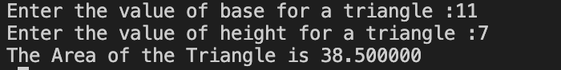

**Q. Write a C program to find out the distance traveled by the equation d=ut+1/2at2.**

**CODE:**

#include<stdio.h>

int main()

{

float u,t,a,d;

printf(“Enter the value of u :”);

scanf(“%f”,&u);

printf(“Enter the value of t :”);

scanf(“%f”,&t);

printf(“Enter the value of a :”);

scanf(“%f”,&a);

d=(u*t)+(0.5*a*t*t);

printf(“The value of distance traveled is %f\n”,d);

return 0;

}

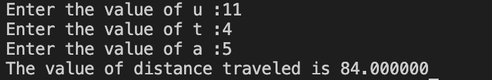

**Q. Write a C program to calculate Simple interest(I)=(PRN/100); where P=Principal Amount, R=Rate of Interest, N=No. of Years.**

**CODE:**

#include<stdio.h>

int main()

{

float I,P,R,N;

printf(“Enter the principal amount:”);

scanf(“%f”,&P);

printf(“Enter the rate of interest:”);

scanf(“%f”,&R);

printf(“Enter the time:”);

scanf(“%f”,&N);

I=(P*R*N)/100;

printf(“The Simple Interest form the given data is %f”,I);

return 0;

}

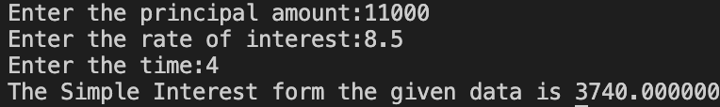

**Q. Write a C program to find the ASCII value of a character.**

**CODE:**

#include<stdio.h>

int main()

{

char c;

printf(“Enter the Character: ”);

scanf(“%c”,&c);

printf(“The ASCII value of %c is %d\n”,c,c);

return 0;

}



**Q. Write a C program that scans an integer from the user and checks whether it is divisible by 3 or not.**

**CODE:**

#include<stdio.h>

int main()

{

int num;

printf("Enter a number: ");

scanf("%d",&num);

if(num%3==0)

{

printf("The entered number is divisible by 3\n");

}

else

{

printf("The entered number is not divisible by 3\n");

}

return 0;

}



**Q. Write a C program to read marks of a student and find whether a student is pass or fail.**

**CODE:**

#include<stdio.h>

int main()

{

int marks;

printf("Enter your marks: ");

scanf("%d",&marks);

if(marks>=33)

{

printf("PASS\n");

}

else

{

printf("FAIL\n");

}

return 0;

}



**Q. Write a C program to check whether a person is eligible for voting or not.**

**CODE:**

#include<stdio.h>

int main()

{

int age;

printf("Enter your age: ");

scanf("%d",&age);

age>=18 ? printf("YOU CAN VOTE\n") : printf("YOU CANNOT VOTE\n");

return 0;

}



**Q. Write a C program that read marks of a student and your program should display an equivalent grade according to the following table:**

**MARKS GRADE**

**100-80 DISTINCTION**

**79-60 FIRST CLASS**

**59-40 SECOND CLASS**

**<40 FAIL**

**CODE:**

#include<stdio.h>

int main()

{

int marks;

printf("Enter your marks(0-100): ");

scanf("%d",&marks);

if(100>=marks && marks>=80)

{

printf("YOU ARE PASSED WITH DISTINCTION\n");

}

else if(79>=marks && marks>=60)

{

printf("YOU ARE PASSED WITH FIRST CLASS\n");

}

else if(59>=marks && marks>=40)

{

printf("YOU ARE PASSED WITH SECOND CLASS\n");

}

else if(40>marks)

{

printf("YOU ARE FAIL\n");

}

else

{

printf("ERROR");

}

return 0;

}



**Q. Write a C program which takes the age of the user as an input and shows how many seconds he has lived.**

**CODE:**

#include<stdio.h>

int main()

{

float age;

printf("Enter your age: ");

scanf("%f",&age);

printf("YOU LIVED %f seconds",age*86400*365);

return 0;

}



**Q. Write a C program that reads numbers from 1 to 7 and print the day relatively from monday to sunday.**

**CODE:**

#include<stdio.h>

int main()

{

int num;

printf("Enter a number(1-7) for a day in a week: ");

scanf("%d",&num);

switch (num)

{

case 1: printf("MONDAY\n");

break;

case 2: printf("TUESDAY\n");

break;

case 3: printf("WEDNESDAY\n");

break;

case 4: printf("THURSDAY\n");

break;

case 5: printf("FRIDAY\n");

break;

case 6: printf("SATURDAY\n");

break;

case 7: printf("SUNDAY\n");

break;

default: printf("ERROR\n");

break;

}

return 0;

}



**Q. Write a C program to check whether the entered number is Capital or small or digit.**

**CODE:**

#include<stdio.h>

int main()

{

char ch;

printf("Enter a character or a digit: ");

scanf("%c",&ch);

if(ch>=0 || ch<=0)

{

printf("THE ENTERED NUMBER IS A DIGIT.\n");

}

else if(ch>= 'a' && ch<= 'z')

{

printf("THE ENTERED NUMBER IS A LOWERCASE ALPHABET.\n");

}

else if(ch>= 'A' && ch<= 'Z')

{

printf("THE ENTERED NUMBER IS A UPPERCASE ALPHABET.\n");

}

else if(ch== '*' || ch== '$' || ch== '#' || ch== '@')

{

printf("THE ENTERED NUMBER IS A SPECIAL CHARACTER.\n");

}

else

{

printf("ERROR\n");

}

return 0;

}



**Q. Write a C program to find the accepted number is positive or negative or zero.**

**CODE:**

#include<stdio.h>

int main()

{

int num;

printf("Enter a number: ");

scanf("%d",&num);

if(num>0)

{

printf("POSITIVE\n");

}

else if(num<0)

{

printf("NEGATIVE\n");

}

else

{

printf("ZERO\n");

}

return 0;

}



**Q. Write a C program to enter a distance in kilometers and convert it into meters, feets, inches and centimeters.**

**CODE:**

#include<stdio.h>

int main()

{

float distance,m,cm,ft,in;

printf("Enter the distance(in km): ");

scanf("%f",&distance);

m=distance*1000;

ft=distance*3280.84;

in=distance*39370.10;

cm=distance*100000;

printf("METERS: %.2f m\n",m);

printf("INCHES: %.2f in\n",in);

printf("FEETS: %.2f ft\n",ft);

printf("CENTI-METERS: %.2f cm\n",cm);

return 0;

}

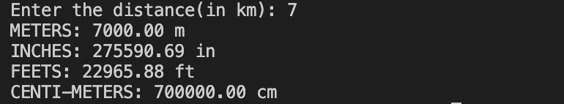

**Q. Write a C program to take the temperature from the user in fahrenheit and display the temperature in celsius.**

**CODE:**

#include<stdio.h>

int main()

{

float f,c;

printf("Enter the temperature(in fahrenheit): ");

scanf("%f",&f);

c=(f-32)*5/9;

printf("The temperature in celsius is %.2f\n",c);

return 0;

}



**Q. Write a C program to calculate profit and loss.**

**CODE:**

#include<stdio.h>

int main()

{

int p,l,sp,cp;

printf("Enter the cost price: ");

scanf("%d",&cp);

printf("Enter the selling price: ");

scanf("%d",&sp);

if(sp>cp)

{

printf("PROFIT BY %d\n",sp-cp);

}

else if(cp>sp)

{

printf("LOSS BY %d\n",cp-sp);

}

else

{

printf("NO PROFIT NO LOSS\n");

}

return 0;

}

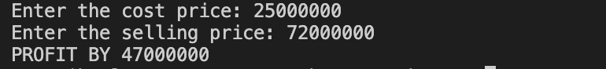

**Q. Write a C program to input the amount of money from the user and print the amount of notes (2000,500,200,100,50,20,10,5,2,1) for the amount.**

**CODE:**

#include<stdio.h>

int main()

{

int amount,n2000,n500,n200,n100,n50,n20,n10,n5,n2,n1;

n2000=n500=n200=n100=n50=n20=n10=n5=n2=n1=0;

printf("Enter the amount of money: ");

scanf("%d",&amount);

if(amount>=2000)

{

n2000=amount/2000;

amount-=n2000*2000;

printf("2000 NOTES: %d\n",n2000);

}

if(amount>=500)

{

n500=amount/500;

amount-=n500*500;

printf("500 NOTES: %d\n",n500);

}

if(amount>=200)

{

n200=amount/200;

amount-=n200*200;

printf("200 NOTES: %d\n",n200);

}

if(amount>=100)

{

n100=amount/100;

amount-=n100*100;

printf("100 NOTES: %d\n",n100);

}

if(amount>=50)

{

n50=amount/50;

amount-=n50*50;

printf("50 NOTES: %d\n",n50);

}

if(amount>=20)

{

n20=amount/20;

amount-=n20*20;

printf("20 NOTES: %d\n",n20);

}

if(amount>=10)

{

n10=amount/10;

amount-=n10*10;

printf("10 NOTES: %d\n",n10);

}

if(amount>=5)

{

n5=amount/5;

amount-=n5*5;

printf("5 NOTES: %d\n",n5);

}

if(amount>=2)

{

n2=amount/2;

amount-=n2*2;

printf("2 NOTES: %d\n",n2);

}

if(amount>=1)

{

n1=amount;

printf("1 NOTES: %d\n",n1);

}

// printf("2000 NOTES: %d\n",n2000);

// printf("500 NOTES: %d\n",n500);

// printf("200 NOTES: %d\n",n200);

// printf("100 NOTES: %d\n",n100);

// printf("50 NOTES: %d\n",n50);

// printf("20 NOTES: %d\n",n20);

// printf("10 NOTES: %d\n",n10);

// printf("5 NOTES: %d\n",n5);

// printf("2 NOTES: %d\n",n2);

// printf("1 NOTES: %d\n",n1);

}

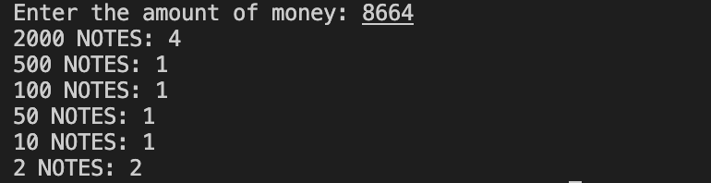

**Q. Write a program to perform Addition, Subtraction, Multiplication and Division of 2**

**numbers as per user’s choice (using if…else/Nested if/Ladder if).**

**CODE:**

#include<stdio.h>

int main()

{

char ch;

int a,b;

printf("Enter the operation: ");

scanf("%c",&ch);

printf("Enter two numbers: ");

scanf("%d%d",&a,&b);

if(ch=='+')

{

printf("%d",a+b);

}

if(ch=='-')

{

printf("%d",a-b);

}

if(ch=='*')

{

printf("%d",a*b);

}

if(ch=='/')

{

printf("%d",a/b);

}

return 0;

}

**Q. Write a C program that reads 5 numbers and sum of all odd values between them.**

**CODE:**

#include<stdio.h>

int main()

{

int i,n[5],sum=0;

for(i=0;i<5;i++)

{

printf("Enter element %d: ",i+1);

scanf("%d",&n[i]);

}

for(i=0;i<5;i++)

{

if(n[i]%2!=0)

{

sum+=n[i];

}

}

printf("%d\n",sum);

return 0;

}

Q. Write a program to find the sum of the first N odd numbers. Ex. 1+3+5+7+………..+N

#include <stdio.h>

int main()

{

int n, i, sum=0;

printf("Enter the value of n: ");

scanf("%d",&n);

for(i=1; i<=n; i++)

{

if(i%2 != 0)

{

if(i == n)

{

printf("%d",i);

}

else

{

printf("%d + ",i);

}

sum = sum + i;

}

}

printf("\nSum of first %d odd numbers is %d\n",n , sum);

return 0;

}

Q. Write a C program to reverse the given number.

CODE:

​​#include<stdio.h>

int main()

{

int n,i=1;

printf("Enter a number: ");

scanf("%d",&n);

printf("The reverse of number is ");

do

{

printf("%d",n%10);

n/=10;

}while(n!=0);

printf("\n");

return 0;

}

**Q. Write a C program to display the cube of the number up to a given integer.**

**CODE:**

#include<stdio.h>

int main()

{

int i,n;

printf("Enter a number: ");

scanf("%d",&n);

for(i=1;i<=n;i++)

{

printf("The cube of %d is %d\n",i,i*i*i);

}

return 0;

}

**Q. Write a C program to print a multiplication table with the use of a for loop.**

**CODE:**

#include<stdio.h>

int main()

{

int n,i;

printf("Enter a number: ");

scanf("%d",&n);

for(i=1;i<=12;i++)

{

printf("%d x %d = %d\n",n,i,n*i);

}

return 0;

}

**Q. Write a C program to print:**

**1**

**1 2**

**1 2 3**

**1 2 3 4**

**1 2 3 4 5**

**CODE:**

#include<stdio.h>

int main()

{

int i,j;

for(i=1;i<=5;i++)

{

for(j=1;j<=i;j++)

{

printf("%d",j);

}

printf("\n");

}

return 0;

}

**Q. Write a C program to print:**

**1**

**12**

**123**

**1234**

**12345**

**CODE:**

#include<stdio.h>

int main()

{

int i,j,k;

for(i=1;i<=5;i++)

{

for(k=i;k<5;k++)

{

printf(" ");

}

for(j=1;j<=i;j++)

{

printf("%d",j);

}

printf("\n");

}

return 0;

}

**Q. Write a C program to print:**

**1 2 3 4 5**

**1 2 3 4**

**1 2 3**

**1 2**

**1**

**CODE:**

#include<stdio.h>

int main()

{

int i,j;

for(i=5;i>=1;i--)

{

for(j=1;j<=i;j++)

{

printf("%d",j);

}

printf("\n");

}

return 0;

}

**Q. Write a C program to print:**

**5 4 3 2 1**

**5 4 3 2**

**5 4 3**

**5 4**

**5**

**CODE:**

#include<stdio.h>

int main()

{

int i,j;

for(i=1;i<=5;i++)

{

for(j=5;j>=i;j--)

{

printf("%d",j);

}

printf("\n");

}

return 0;

}

**Q. Write a C program to print:**

**5 5 5 5 5**

**4 4 4 4**

**3 3 3**

**2 2**

**1**

**CODE:**

#include<stdio.h>

int main()

{

int i,j;

for(i=5;i>=1;i--)

{

for(j=1;j<=i;j++)

{

printf("%d",i);

}

printf("\n");

}

return 0;

}

**Q. Write a C program to print:**

**1**

**2 2**

**3 3 3**

**4 4 4 4**

**5 5 5 5 5**

**CODE:**

#include<stdio.h>

int main()

{

int i,j;

for(i=1;i<=5;i++)

{

for(j=1;j<=i;j++)

{

printf("%d",i);

}

printf("\n");

}

return 0;

}

**Q. Write a C program to print:**

**A**

**A B**

**A B C**

**A B C D**

**A B C D E**

**CODE:**

#include<stdio.h>

int main()

{

char i,j;

for(i='A';i<='E';i++)

{

for(j='A';j<=i;j++)

{

printf("%c",j);

}

printf("\n");

}

return 0;

}

**Q. Write a C program to print:**

**A**

**B B**

**C C C**

**D D D D**

**E E E E E**

**CODE:**

#include<stdio.h>

int main()

{

char i,j;

for(i='A';i<='E';i++)

{

for(j='A';j<=i;j++)

{

printf("%c",j);

}

printf("\n");

}

return 0;

}

**Q. Write a C program to print:**

**A B C D E**

**A B C D**

**A B C**

**A B**

**A**

**CODE:**

#include<stdio.h>

int main()

{

char i,j;

for(i='E';i>='A';i--)

{

for(j='A';j<=i;j++)

{

printf("%c",j);

}

printf("\n");

}

return 0;

}

**Q. Write a C program to print:**

**E E E E E**

**D D D D**

**C C C**

**B B**

**A**

**CODE:**

#include<stdio.h>

int main()

{

char i,j;

for(i='E';i>='A';i--)

{

for(j='A';j<=i;j++)

{

printf("%c",i);

}

printf("\n");

}

return 0;

}

**Q. Write a C program to print:**

**1**

**1 0**

**1 0 1**

**1 0 1 0**

**1 0 1 0 1**

**CODE:**

#include<stdio.h>

int main()

{

int i,j;

for(i=1;i<=5;i++)

{

for(j=1;j<=i;j++)

{

printf("%d",j%2);

}

printf("\n");

}

return 0;

}

**Q. Write a C program to print:**

*

* *

* * *

* * * *

* * * * *

**CODE:**

#include<stdio.h>

int main()

{

int i,j,s;

for(i=1;i<=5;i++)

{

for(s=i;s<5;s++)

{

printf(" ");

}

for(j=1;j<=i;j++)

{

printf(" *");

}

printf("\n");

}

return 0;

}

**Q. Write a C program to print:**

**\* * * * \***

**\* * * \***

**\* * \***

**\* \***

**\***

**CODE:**

#include<stdio.h>

int main()

{

int i,j,s;

for(i=5;i>=1;i--)

{

for(s=i;s<5;s++)

{

printf(" ");

}

for(j=1;j<=i;j++)

{

printf(" *");

}

printf("\n");

}

return 0;

}

**Q. Write a C program to print:**

**\***

**\* \***

**\* * \***

**\* * * \***

**\* * * * \***

**\* * * \***

**\* * \***

**\* \***

**\***

**CODE:**

#include<stdio.h>

int main()

{

int i,j,s;

for(i=1;i<=5;i++)

{

for(s=i;s<5;s++)

{

printf(" ");

}

for(j=1;j<=i;j++)

{

printf(" *");

}

printf("\n");

}

for(i=4;i>=1;i--)

{

for(s=i;s<5;s++)

{

printf(" ");

}

for(j=1;j<=i;j++)

{

printf(" *");

}

printf("\n");

}

return 0;

}

**Q. Write a C program to multiply a 3x3 matrix.  
CODE:**

#include<stdio.h>

int main()

{

int a[3][3]={{1,1,1},{2,2,2},{3,3,3}};

int b[3][3]={{1,1,1},{2,2,2},{3,3,3}};

int res[3][3];

for(int i=0;i<3;i++)

{

for(int j=0;j<3;j++)

{

res[i][j]=0;

{

for(int k=0;k<3;k++)

{

res[i][j]+=a[i][k]*b[k][j];

}

}

}

}

printf("The product of the two matrix is: \n");

for(int i=0;i<3;i++)

{

for(int j=0;j<3;j++)

{

printf("%d\t",res[i][j]);

}

printf("\n");

}

return 0;

}

**Q. Write a C program to add two matrices.**

**CODE:**

#include<stdio.h>

int main()

{

int a[3][3]={{1,1,1},{2,2,2},{3,3,3}};

int b[3][3]={{1,1,1},{2,2,2},{3,3,3}};

int res[3][3];

for(int i=0;i<3;i++)

{

for(int j=0;j<3;j++)

{

res[i][j]=0;

res[i][j]=a[i][j]+b[i][j];

}

}

printf("The addition of the two matrix is: \n");

for(int i=0;i<3;i++)

{

for(int j=0;j<3;j++)

{

printf("%d\t",res[i][j]);

}

printf("\n");

}

return 0;

}

**Q. Write a C program to calculate the square of the number using library functions.**

**CODE:**

#include<stdio.h>

#include<math.h>

int main()

{

int n;

printf("Enter a number: ");

scanf("%d",&n);

printf("The square of %d is %.2f\n",n,pow(n,2));

return 0;

}

**Q. Write a C program to add two numbers using a function**

**CODE:**

#include<stdio.h>

int add(int,int);

int main()

{

add(5,11);

}

int add(int a,int b)

{

printf("First number: %d\nSecond number: %d\n",a,b);

printf("The sum of given two number is %d\n",a+b);

return 0;

}

**Q. Write a C program to swap two numbers using a function.**

**CODE:**

#include<stdio.h>

int swap();

int main()

{

swap();

}

int swap()

{

int a,b;

//int temp;

printf("Enter two numbers: ");

scanf("%d%d",&a,&b);

printf("Before swapping\nFirst number: %d and Second number: %d\n",a,b);

a=a+b;

b=a-b;

a=a-b;

//temp=a;

//a=b;

//b=temp;

printf("After swapping\nFirst number: %d and Second number: %d\n",a,b);

return 0;

}

**Q. Write a C program to check whether the number is prime or not using a function.**

**CODE:**

#include<stdio.h>

int prm();

int main()

{

prm();

}

int prm()

{

int i,n,count=0;

printf("Enter a number: ");

scanf("%d",&n);

for(i=1;i<=n;i++)

{

if(n%i==0)

{

count++;

}

}

if(count==2)

{

printf("Number is Prime\n");

}

else

{

printf("Number is Not Prime\n");

}

return 0;

}

**Q. Write a C program to give detail about 5 students using structure.**

**CODE:**

#include<stdio.h>

struct student

{

char name[5];

int rollno;

int phone;

}s[5];

int main()

{

int i;

printf("Enter the details of 5 students.\n");

for(i=0;i<5;i++)

{

printf(">>Enter details of student %d\n",i+1);

printf("\tEnter the name: ");

scanf("%s",s[i].name);

printf("\tEnter the roll number: ");

scanf("%d",&s[i].rollno);

printf("\tEnter the phone number: ");

scanf("%d",&s[i].phone);

}

printf("\n");

for(i=0;i<5;i++)

{

printf(">>Details for Student %d\n",i+1);

printf("\tName: %s\n",s[i].name);

printf("\tRoll Number: %d\n",s[i].rollno);

printf("\tPhone Number: %d\n",s[i].phone);

}

return 0;

}

#include <stdio.h>

void main()

{

int num,r,c;

static int i=1;

static char ch='A';

printf("Enter the numbers of rows= ");

scanf("%d",&num);

for(r=1;r<=num;r++)

{

for(c=1;c<=r;c++)

{

if(r%2==0)

printf("%c",ch++);

else

printf("%d",i++);

}

printf("\n");

}